Physical Layer and Media (Part 1)

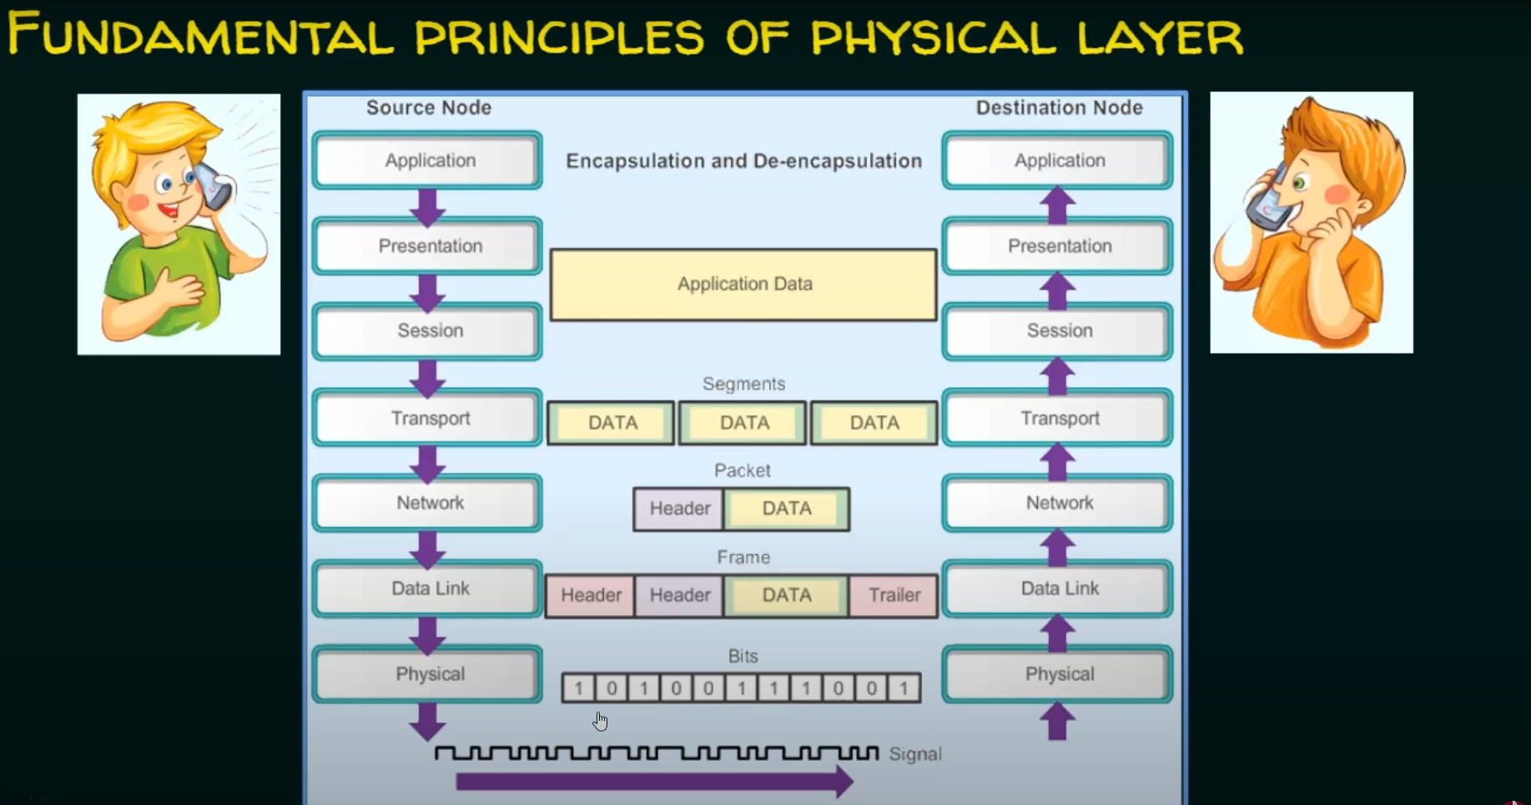

Data and Signals

1. source/destination → data → signals
2. 4 important points:
   1. One of the major functions of the physical layer is to move data in the form of electromagnetic signals across a transmission medium
   2. The data usable to a person or an application are not in a form that can be transmitted over a network.
   3. For example, an image must first be changed to a form that transmission media can accept
   4. To be transmitted, data must be transformed to electromagnetic signals.